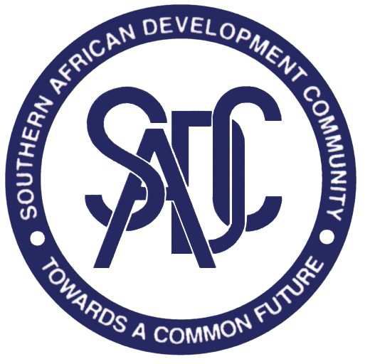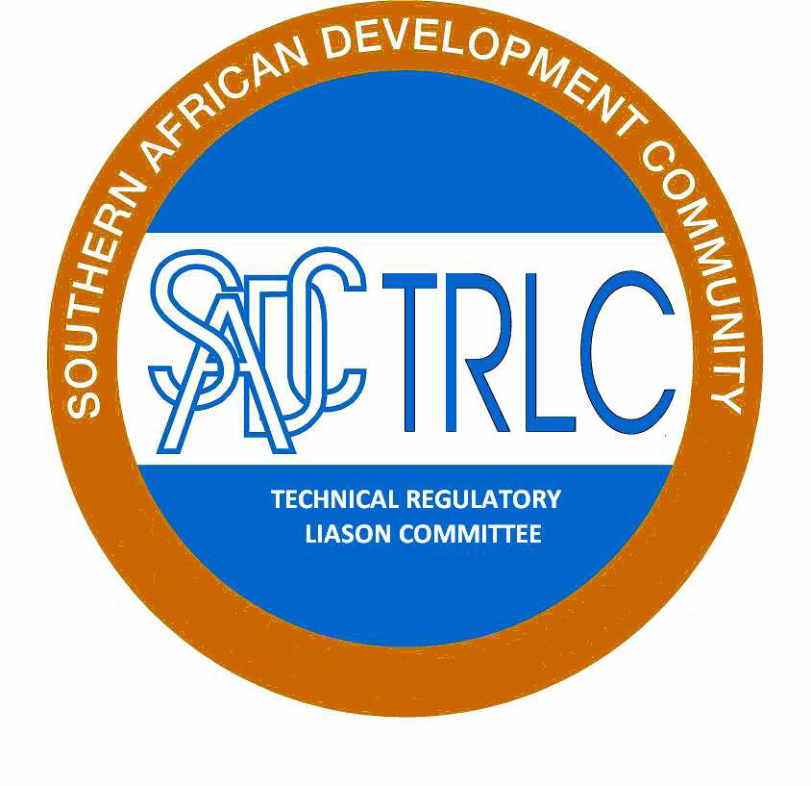

SADCTRLC Annual Meeting Resolutions for 17 March 2016

Resolution 1/2016
SADCTRLC noted the welcome by the Chairperson, and noted the presence of 11 member states, which constituted a quorum. An apology was received from Lesotho.

Resolution 2/2016
SADCTRLC noted the presentation on the development of the 5 year strategic plan. MSs are requested to submit proposals for consideration at the EWG meeting that is planned to take place during the month of April 2016. The proposals to be submitted by the 7th April 2016.

Resolution 3/2016
SADCTRLC noted the progress with the SADC Baseline Study on Technical Regulations affecting Trade in SADC: Major differences in priorities for harmonisation. The MSs, namely, Botswana, Zambia, Zimbabwe, Lesotho, and Mauritius are expected to validate the report before the end of May 2016. The SADCTRLC AGM endorsed the Model to analyse the TRs that were identified as part of the base line study. SADCTRLC members agreed to 5 TRs that will be used as pilot project. The EWG will meet during the month of April 2016.

Resolution 4/2016
SADCTRLC AGM recommended and assigned the SADCTRLC EWG to develop the procedures to be used for harmonization of TRs by the next SADCTRLC AGM.

Resolution 5/2016
SADCTRLC noted the progress on the Guidelines for Impact and Risk Assessment. Members endorsed the following way forward:

- Workshop under REIS project for those Member States that did not participate in the RIA training supported by the PTB and REIS. This item shall be implemented before the end June 2016.
- Common slides will be developed by SADCTRLC EXCO to assist those that were trained to replicate the training in their Member States in a uniform way. The slide presentation shall be developed before the end of May 2016.
- PTB is willing to support Member States with some of the logistical costs for the National roll-out.
- Member States will be expected to report on progress, bi-annually as part of their country reports.

Resolution 6/2016
SADCTRLC noted the progress made with the SADCTRLC website (www.sadctrlc.org).

- SADCTRLC website is functional and MSs are encouraged to use the website from now on.
- The approach is that SADCTRLC will upload all communications to the SADCTRLC website however indicate, via the email, that there is new information uploaded on the SADCTRLC Website.
- Log-ins for PTB and SADC Secretariat is also being provided.

Resolution 7/2016

The GHS survey questionnaire was sent to all 15 MSs. seven (7) MSs participated in the GHS survey, namely Botswana, Madagascar, Namibia, South Africa, Swaziland, Zimbabwe and Zambia. The survey results demonstrate that five MSs require 240 copies of the GHS policy document and training for 186 participants. PTB requires that MSs fill-in the PTB request form for assistance. MSs that did not participate are all also requested to submit their proposals, including the PTB request form, to the SADCTRLC secretariat by the 7th April 2016.

Resolution 8/2016
SADCTRLC noted and thanked the 8 member states that have submitted their member state reports. The SADCTRLC Secretariat will verify the contact list with assistance from the SADC Secretariat by writing letters to the Permanent Secretaries of Member States and also request them to nominate alternates to the SADCTRLC. SADCTRLC members are further requested to notify the SADCTRLC secretariat when they move their position and forward the possible contact details of the new incumbent when available. SADCTRLC proposed that this is incorporated into the revised rules of procedure.

Resolution 9/2016
The draft revised rules of procedures will be circulated by the end of March 2016 to MSs for comments and inputs for 60 days.

Resolution 10/2016
SADCTRLC noted the progress report on the alert system. The agreed way-forward is as follows:

- SADCTRLC continues with the project and use the SADCTRLC website platform. The website will incorporate the interactive page that will allow MSs to communicate non-compliant products in the SADC region.
- SADCTRLC approached PTB to expand the scope of the SADCTRLC website via the NMISA assistance. PTB is willing to assist with the project however advise SADCTRLC AGM that there are legal considerations in this regard. This matter will be taken up with SADC Secretariat for legal guidance.
- The project proposal and ToR shall be finalized during the month of September 2016.

Resolution 11/2016
SADCTRLC noted the progress on the harmonisation of TRs for used motor vehicles. The concept note has been circulated to MSs for further inputs. The MSs are encouraged to provide inputs by 7 April 2016. In all other areas that may be related to second hand vehicles such as second hand tyres and spare parts MSs are requested to submit formal proposals to the SADCTRLC secretariat for consideration by SADCTRLC EXCO.

Resolution 12/2016
SADCTRLC conducted elections for office bearers. The current EXCO was re-elected with changes. The changes are as follows:

SADCTRLC Chair – Swaziland
SADCTRLC Vice Chair – Zambia
SADCTRLC EXCO Members – Botswana and Namibia
SADCTRLC Secretariat – South Africa

SADCTRLC thank the outgoing Chair, Mr Johannes Mosanawe, from Botswana for his excellent services and inputs into the work of the SADCTRLC. SADCTLRC congratulate the new Chair, Ms Phindile Dlamini, from Swaziland.

Resolution 13/2016
SADCTRLC expressed its gratitude for the support received from PTB and the EU REIS programme for SADCTRLC activities in 2015/16.

Resolution 14/2016
SADCTRLC expressed its appreciation to the Government of the Botswana and SADC Secretariat for hosting the 2016 SADCTRLC Annual Meeting.

